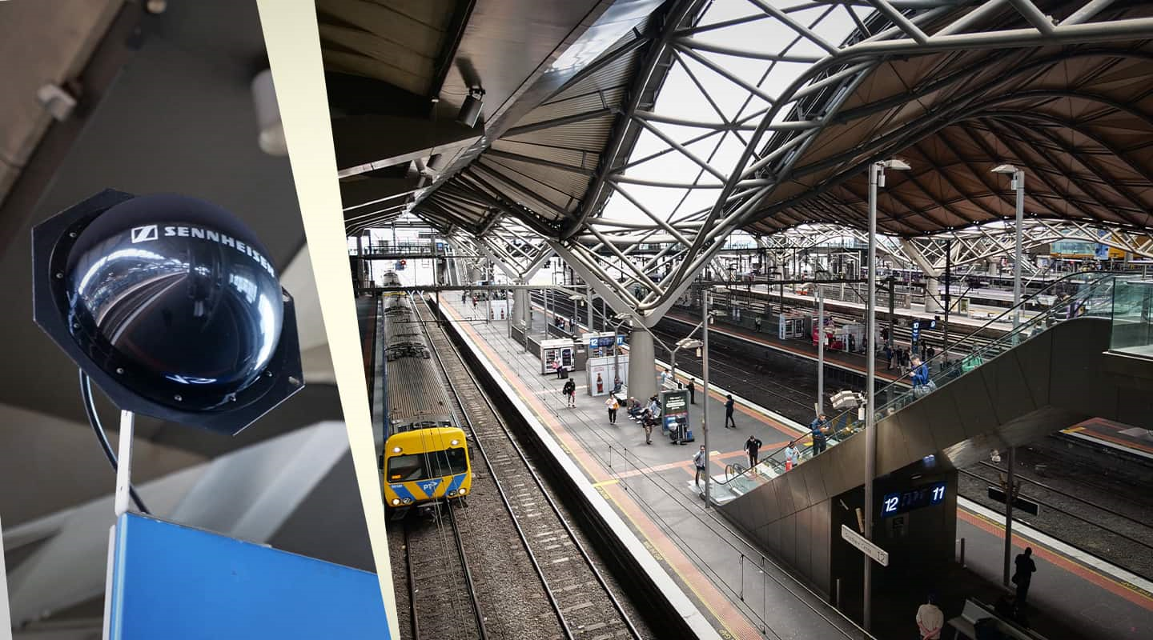Platform Delivery: Melbourne’s Major Public Transport Hub Transforms its Wireless Audio Solutions with Sennheiser
Insight Systems deploys a fit-for-purpose Sennheiser wireless solution that delivers in some of the harshest RF conditions imaginable

Melbourne, 14 December 2023 – Mass communication and mass transit don’t mix. At least, that was Southern Cross Station’s experience. Melbourne’s main train hub for regional rail (as well as a key metro rail hub) had a significant issue with communicating with its customers. The regional rail platforms are up to 300m long and are heaving with would-be travellers during rush hour. Southern Cross Station’s old paging solution was a very blunt instrument: There was no zoning – the whole station (all 16 platforms) got the same message.
InSight Systems is Southern Cross Station’s managed services partner, so when Director of Technology, Myke Ireland, and his team were briefed on an improvement to the station’s announcements capability, they were all ears.

“The officers wanted to freely walk up and down anywhere along a platform and make announcements to the patrons of that platform,” describes Myke Ireland. “The problem is, Southern Cross Station is a natural Faraday cage – it’s where RF goes to die. Not only that, it’s thrumming with high voltage cables, and there’s EMF everywhere – radio and TV stations – not to mention thousands of people soaking up RF. But the sort of wireless system the station was after would need to be exceptionally robust: interference-free, and work every time someone picks up a mic.”
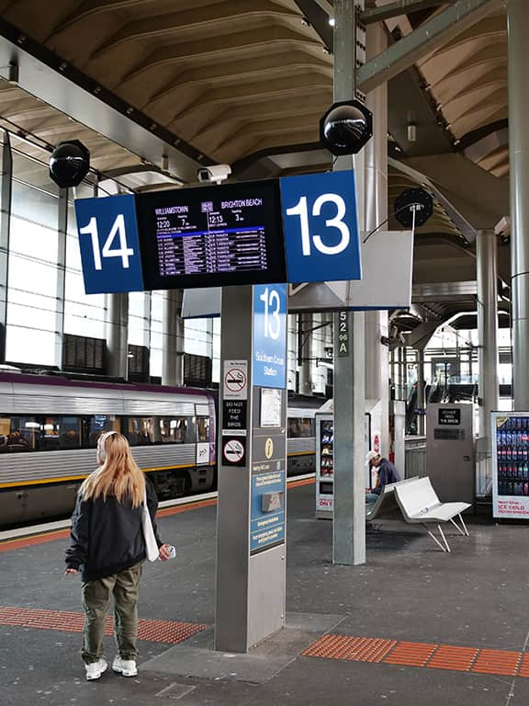 | The Sennheiser A5000-CP and Wireless Systems Manager makes RF coordination “a breeze”.

NEXT-LEVEL ANTENNA
Sennheiser worked with InSight Systems to assist in mapping the four regional train platforms to model the RF environment and help specify the type and quantity of antennas required. As expected, this project would require the big gun, the A5000-CP — the more standard half-/quarter-length ‘paddle’ antennas, normally sufficient in most other contexts, weren’t up to the extreme conditions. The software modelling recommended eight of these helical antennas from Sennheiser for each platform. The antennas are placed at the PIDS (public information display structure) positions. They’re highly directional, which is perfect for the job — each platform is its own zone and intermodulation between platforms would be bad news.

InSight Systems was aware that the ‘black dome’ form factor of the A5000-CP was hard to conceal but ‘needs must’ — performance would need to trump any aesthetic concerns. As it happened a vibrant Reddit thread speculated on the purpose of the A5000-CP units, which were installed during the peak Covid period. Some Redditors suspected the antennas had the capacity to scan commuters’ phones for their vaccine status and, maybe, rayguns would be installed next to quickly dispatch troublemakers.

With this, InSight Systems selected wireless microphone systems from Sennheiser’s G4 range, including ew300 handheld systems, powered antenna combiners, and receivers. No rayguns were specified (but they would say that, though, right?).

KEEPING THE SYSTEM ON TRACK
InSight Systems is using Sennheiser’s Wireless Systems Manager (WSM). WSM is Sennheiser’s professional software solution for remotely monitoring and controlling wireless systems. It displays the entire data of all controlled devices on the network at Southern Cross Station. It shows all status information and makes setting adjustments including firmware updates for one or multiple devices very easy. For example, if there’s a significant change in the RF environment – a new TV station pops up or a RF-heavy boat moors nearby – InSight Systems can remotely scan and re-stack the RF of the receivers.

“The Sennheiser aspects of this job were a breeze,” reflects Myke Ireland. “It was so easy to get all the frequencies we wanted and to get the antennas we needed… Sennheiser made the RF design simple.”

George Sotiriadis, Sales Manager Business Communications VIC/TAS at Sennheiser adds, “When Insight Systems contacted me about this project, naturally I was excited because of the long history and prominence of the Southern Cross Train Station in Melbourne, and because I knew Sennheiser would be able to provide a robust solution that simply and effectively fit the station’s needs and unique environment. Working with Myke & the Insight team in the design phase was a pleasure and it’s gratifying to know that everyone involved with this project is so thrilled with the end result”.
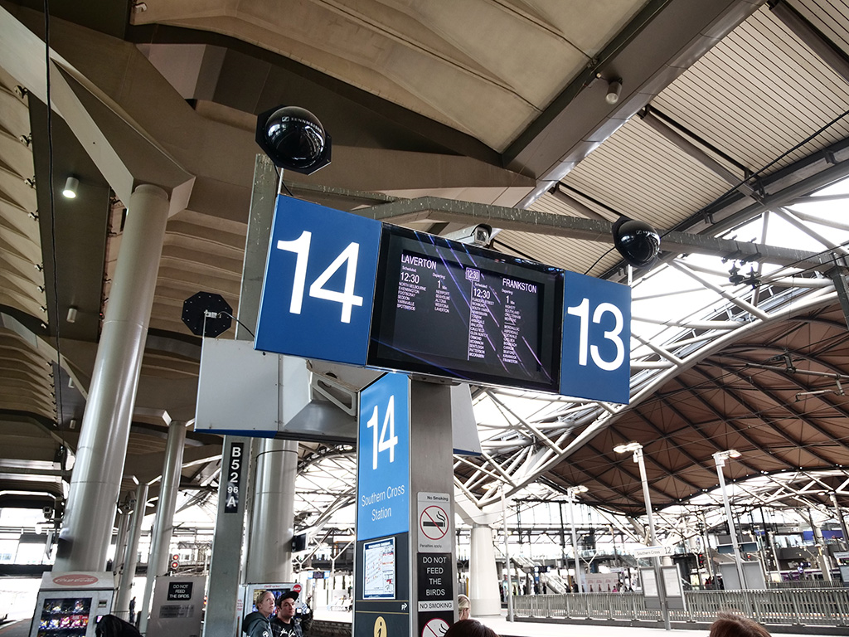
The Sennheiser A5000-CP stood up to the harsh RF environment at Southern Cross rail station.

INFORMATION TECHNOLOGY
Southern Cross Station’s wireless audio upgrade has been highly successful. For commuters, timely and contextual information is key. Previously, the scatter-gun paging approach caused frustrations not only for patrons but for station staff who were stretched thin as they fielded individual enquiries. Now, staff are free to walk the full length of the platforms and make calls specific to the platform at a frequency that works best for the pace and schedule of the platform.

Maybe mass communication and mass transport can mix.
To see more of Sennheiser's wireless solutions at Southern Cross Station, visit here.
About Sennheiser
We live and breathe audio. We are driven by the passion to create audio solutions that make a difference. Building the future of audio and bringing remarkable sound experiences to our customers – this is what the Sennheiser brand has stood for since more than 75 years. While professional audio solutions such as microphones, conference systems, streaming technologies and monitoring systems are part of the business of Sennheiser electronic GmbH & Co. KG, the business with consumer devices such as headphones, soundbars and speech-enhanced hearables is operated by Sonova Holding AG under the license of Sennheiser.

www.sennheiser.com
www.sennheiser-hearing.com

Local Press Contact
Daniella Kohan
daniella.kohan@sennheiser.com
+1 (860) 222-4226

